- Name: Yuan Bao Xiu

- Signature:

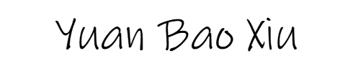

- Payer Name: Ahmed Elkhodary

- Signature:

- Date the contract was signed: 2022-09-15

- A description of the goods or services provided:

Project name:

Mobile app development for the form builder with React Native

Content:

Add the dialog for CRUD actions

Fixed drawing issue in bitmap field

Update the calendar widget field

- Details of the price(s) being charged for the goods or services provided:

Hourly rate: $20

Worked time for the project: 30 hours

Price: 20 \* 30 = $600